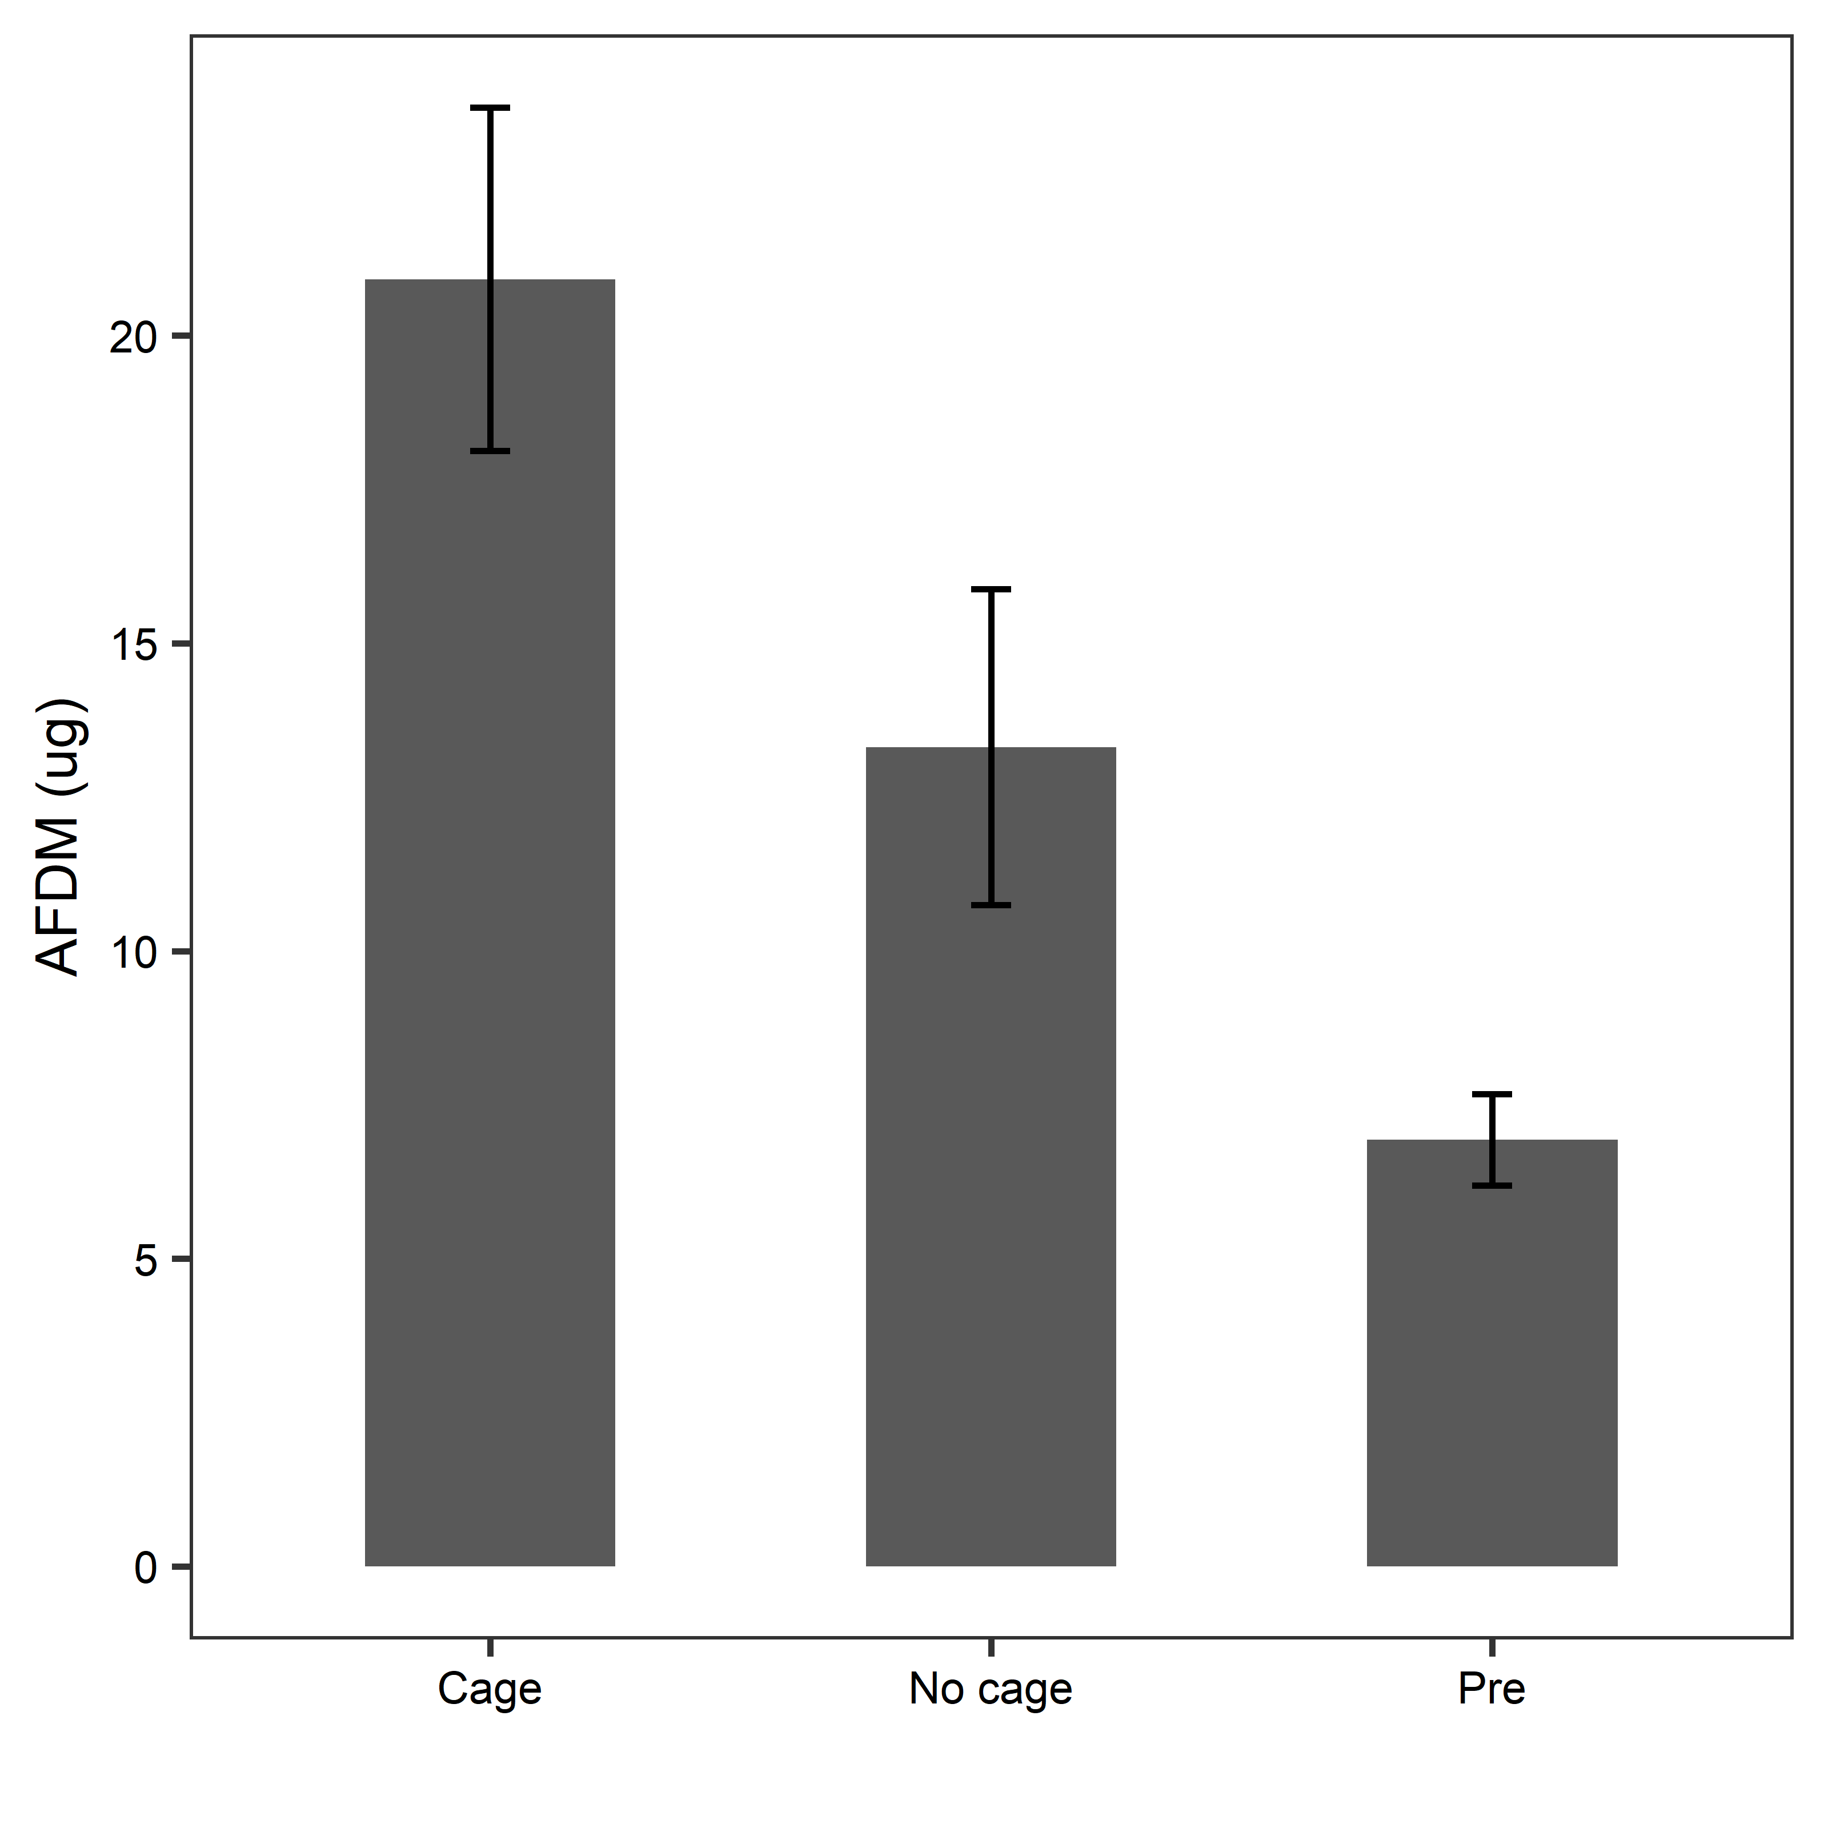

> anova1<-aov(AFDM_adjust~Treatment, data=Filtersbiofilm)

> summary(anova1)

Df Sum Sq Mean Sq F value Pr(>F)

Treatment 2 2305 1152.4 9.504 0.000229 ***

Residuals 68 8245 121.3

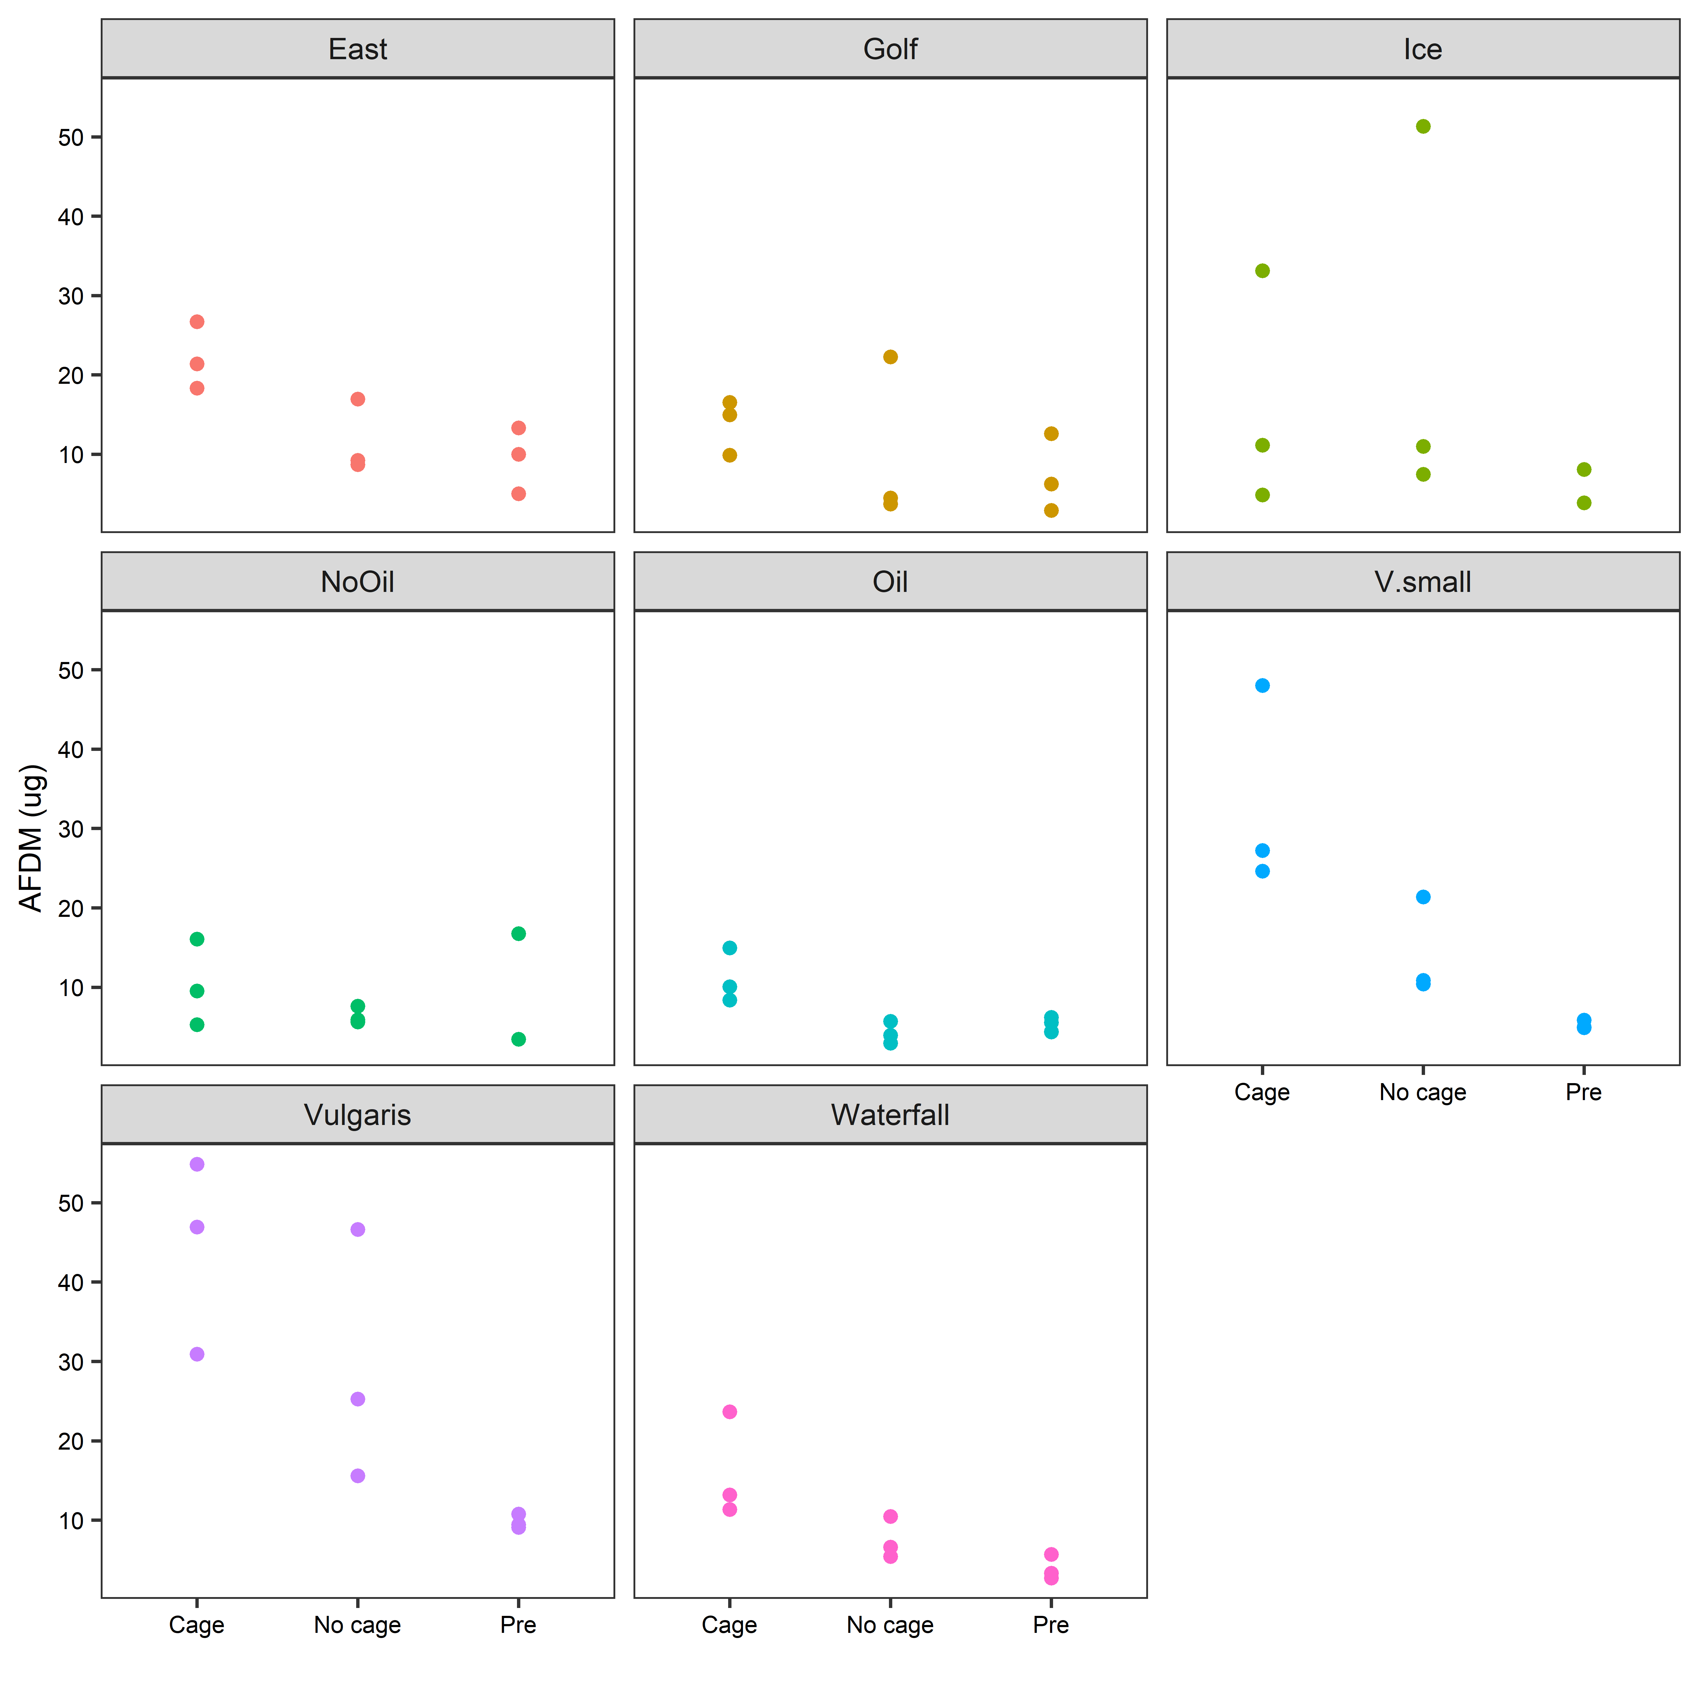

> summary(anova2)

Df Sum Sq Mean Sq F value Pr(>F)

Treatment 2 2305 1152.4 15.302 7.62e-06 ***

Pond 7 2892 413.1 5.485 0.000119 ***

Treatment:Pond 14 1814 129.6 1.720 0.083310 .

Residuals 47 3540 75.3

---

Signif. codes: 0 ‘***’ 0.001 ‘**’ 0.01 ‘*’ 0.05 ‘.’ 0.1 ‘ ’ 1

2 observations deleted due to missingness

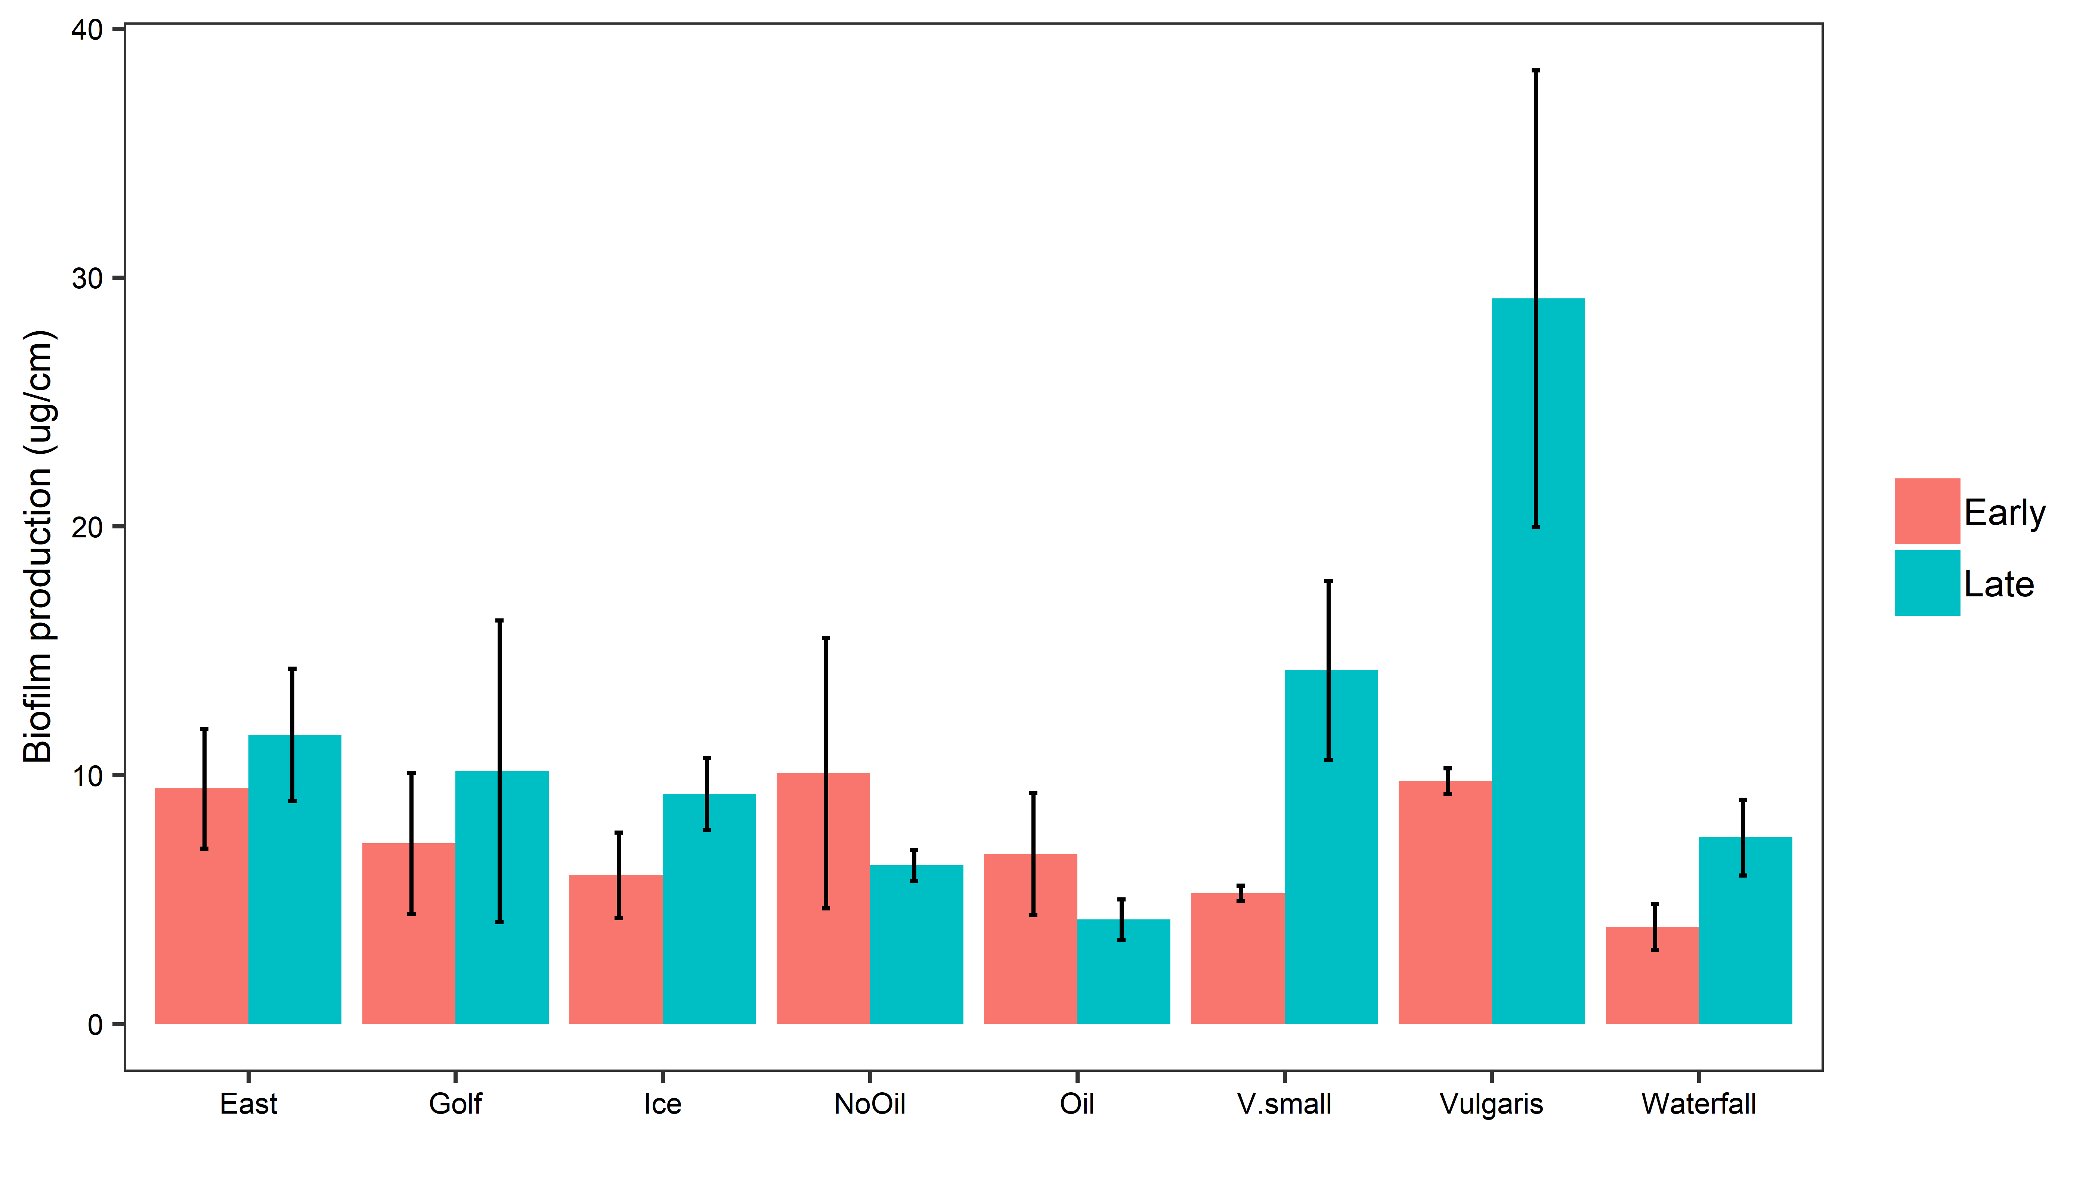

* Increases for every pond except for Oil and NoOil

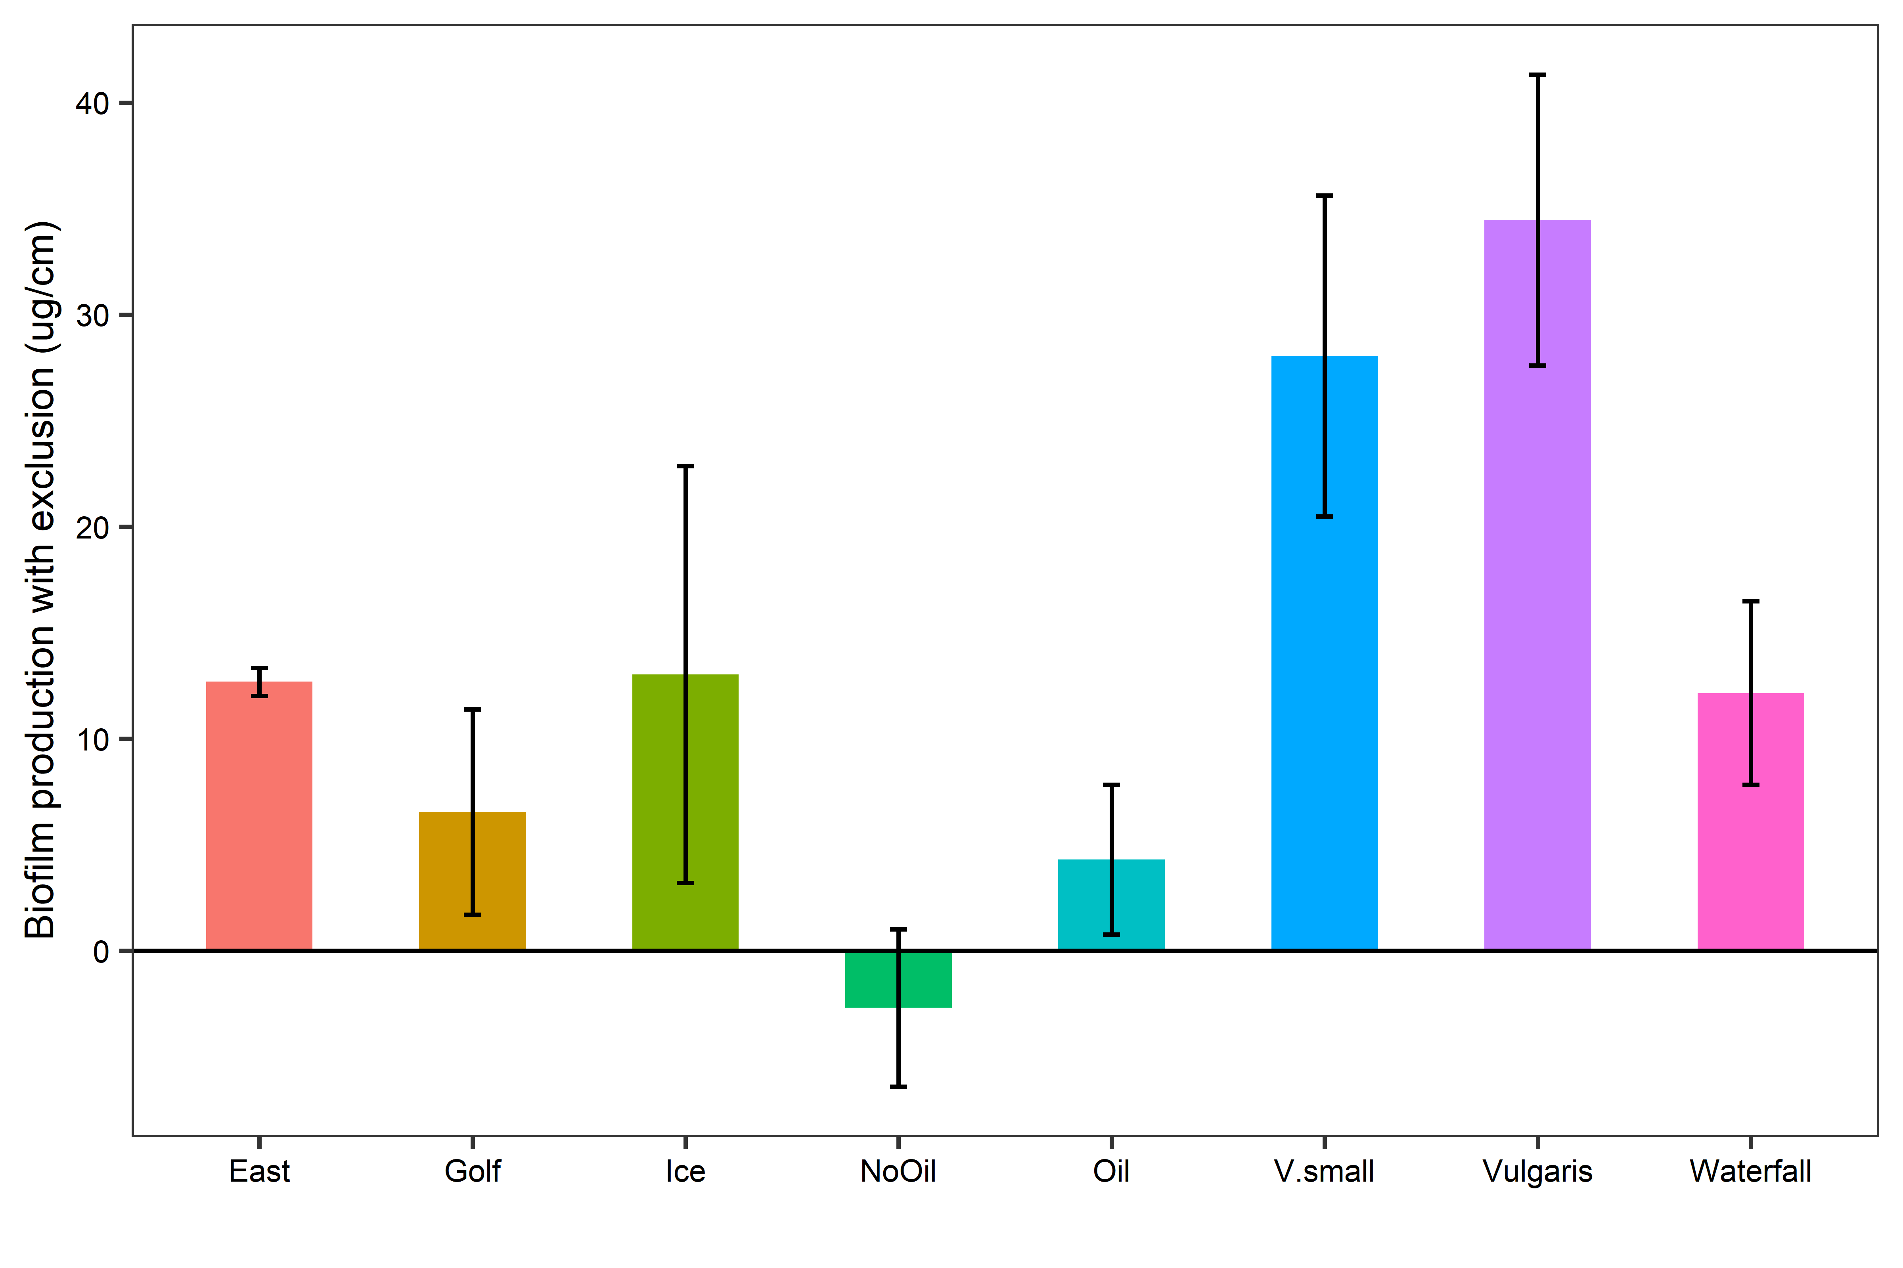

* Cage – pre biofilm. Largest for v.small and vulgaris. Lowest for NoOil, Oil

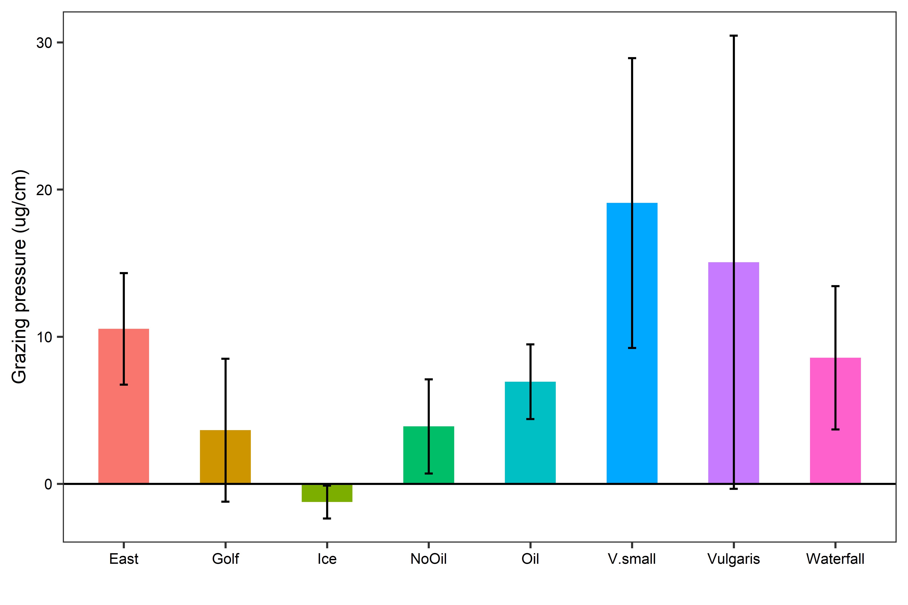

* Cage – Nocage

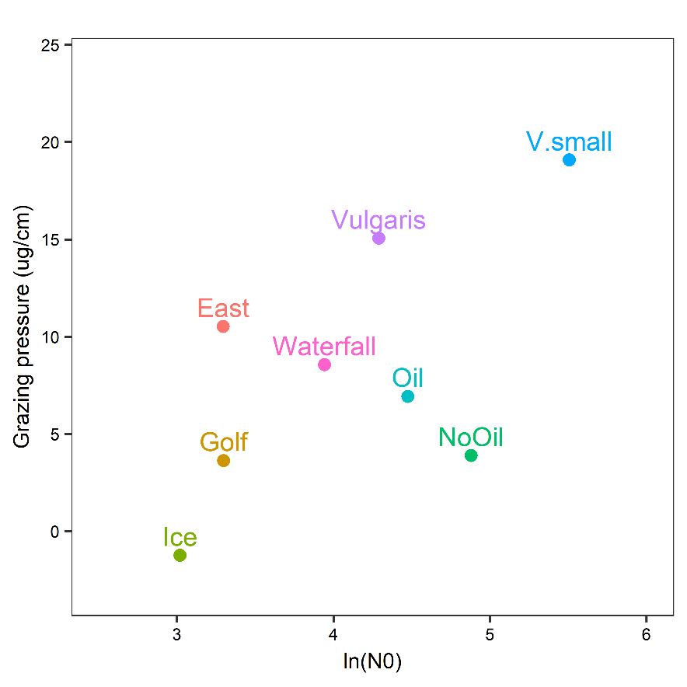

> m1<-lm(Cageminnocage~logN0, data=abundanceandbiofilm)

> summary(m1)

Call:

lm(formula = Cageminnocage ~ logN0, data = abundanceandbiofilm)

Residuals:

Min 1Q Median 3Q Max

-8.1421 -3.5174 -0.0022 4.5164 5.9509

Coefficients:

Estimate Std. Error t value Pr(>|t|)

(Intercept) -10.959 10.085 -1.087 0.3189

logN0 4.714 2.420 1.948 0.0993 .

---

Signif. codes: 0 ‘***’ 0.001 ‘**’ 0.01 ‘*’ 0.05 ‘.’ 0.1 ‘ ’ 1

Residual standard error: 5.541 on 6 degrees of freedom

Multiple R-squared: 0.3874, Adjusted R-squared: 0.2853

F-statistic: 3.795 on 1 and 6 DF, p-value: 0.09933

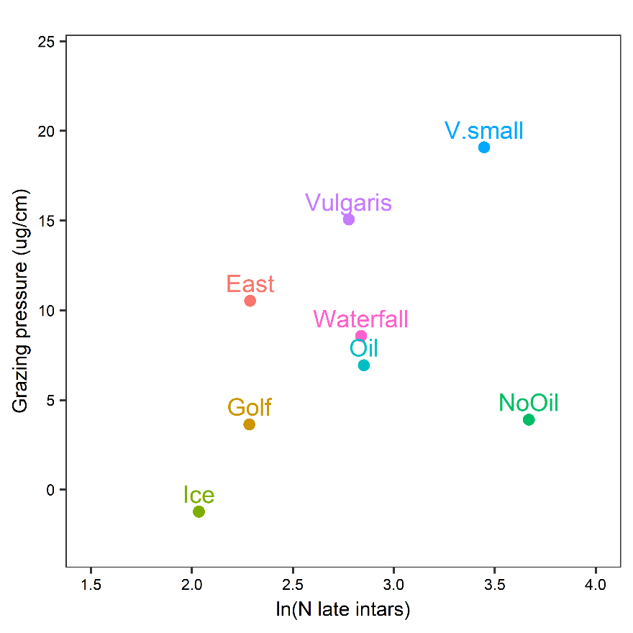

> summary(m2)

Call:

lm(formula = Cageminnocage ~ Log34instars, data = abundanceandbiofilm)

Residuals:

Min 1Q Median 3Q Max

-8.9152 -3.1100 -0.9156 5.1779 7.3821

Coefficients:

Estimate Std. Error t value Pr(>|t|)

(Intercept) -5.652 11.884 -0.476 0.651

Log34instars 5.034 4.207 1.197 0.277

Residual standard error: 6.362 on 6 degrees of freedom

Multiple R-squared: 0.1927, Adjusted R-squared: 0.05812

F-statistic: 1.432 on 1 and 6 DF, p-value: 0.2766